Update a file through a Python algorithm

Project description

At my organization, access to restricted content is controlled with an allow list of IP addresses. The "allow_list.txt" file identifies these IP addresses.

A separate remove list identifies IP addresses that should not have access to this content. I created an algorithm to automate updating the "allow_list.txt" file and remove these IP addresses that should no longer have access.

For the first part of the algorithm, I opened the "allow_list.txt" file., I assigned this file name as a string to the import_file variable:

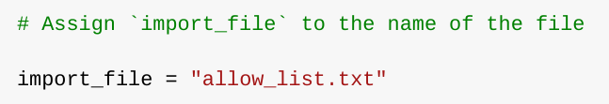

I used a with statement to open the file:

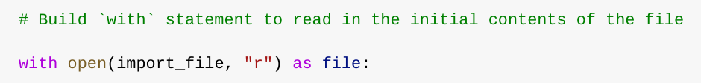

Read the file contents

In order to read the file contents, I used the .read() method to convert it into string.

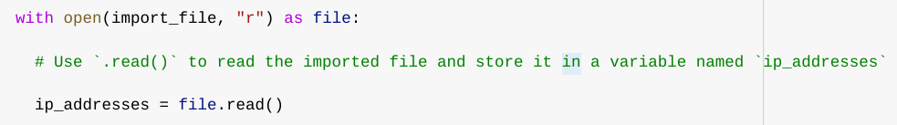

When using an .open() function that includes the argument "r" for “read,” you can call the .read() function in the body of the with statement. The .read() method converts the file into string and allows one to read it. I applied the .read() method to the file variable identified in the with statement. Then, assigned the string output of this method to the variable of ip_addresses.

In order to remove individual IP addresses from the allow list, I needed it to be in list format. Therefore, I next used the .split() method to convert the ip_addresses string into a list:

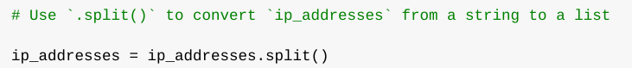

Iterate through the remove list

A key part of my algorithm involves iterating through the IP addresses that are elements in the remove_list. To do this, I incorporated a for loop:

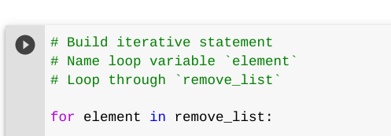

Remove IP addresses

The algorithm requires removing any IP address from the allow list, ip_addresses, that is also contained in remove_list.  Because there were not any duplicates in ip_addresses, following the below code:

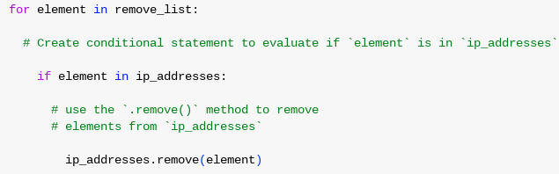

Then, within that conditional, I applied .remove() to ip_addresses. I passed in the loop variable element as the argument so that each IP address that was in the remove_list would be removed from ip_addresses.

Update the file with the revised list of IP addresses



Then, I used another with statement and the .write() method to update the file:

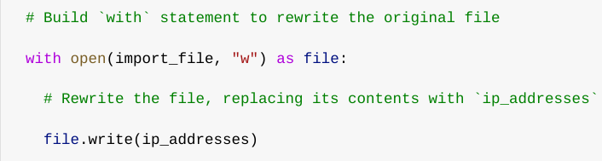

In this case I wanted to write the updated allow list as a string to the file "allow_list.txt". This way, the restricted content will no longer be accessible to any IP addresses that were removed from the allow list. To rewrite the file, I appended the .write() function to the file object file that I identified in the with statement. I passed in the ip_addresses variable as the argument to specify that the contents of the file specified in the with statement should be replaced with the data in this variable.

Summary

I created an algorithm that removes IP addresses identified in a remove_list variable from the "allow_list.txt" file of approved IP addresses.

This algorithm involved opening the file, converting it to string to be read, and then to a list stored in the variable ip_addresses. I then iterated through IP addresses in remove_list. I evaluated if the element was part of the ip_addresses list. applied the .remove() method to it to remove the element from ip_addresses. I used the .join() method to convert the ip_addresses into string so that I could write over the contents of the "allow_list.txt" file with the revised list of IP addresses.